|  |  |  |  |  |  |  |  |  |
| --- | --- | --- | --- | --- | --- | --- | --- | --- |
| |  | | --- | | Friday 14th October 2016  The Mill Messenger | |  | |  | |  | |  | | --- | | Stars of the Week: Congratulations to: Ciara, Jaden, Amy, Kian, Oliver J, Daisy, Maryam, Christopher, Emily, Joseph, Amy, Ellie, Alfie P and Keyaan.  **House Cup Winners:**  Congratulation to the Integrity house for winning this week with an impressive score of 29 points.  **Attendance Cup Winners**  Congratulations to Rousseau class in Year 5. The attendance for the week is of 99%. Well done - take a bow you are this week’s attendance cup winners!  **Room 13 Committee**  Adam, Destiny, Mabelle, Miriam Qaylah, Leo, Angel Katie  **School Council Representatives**  Lichtenstein – Freddie and Ali Goldsworthy - Connie and Morgan Hokusai - Faith and Teddy Mondrian – Evie and Harry Moore - Holly and Faris Miro - Aaliyah and Rico Rousseau – Layla and Harley Van Gogh – Holly and Idris Riley – Emile and Reggie da Vinci –Jessica and Evan  T:\Teaching 2016 - 17\IMG_0121.JPG | |  | | **Key Dates:**  **Parents Evening**– Monday 17th and Tuesday 18th October  **Non Uniform Day –** Friday 21st October  **Half Term –** Monday 24th – Friday 28th October  **Christmas Fair –** Friday 9th December  **Christmas Performances -** Monday 12th and Tuesday 13th December  **Last day of Term** – Friday 16th December | |

*“Things that matter most should never be at the mercy of things that matter least!”*  Goethe

Dear Mums, Dads and Carers,

This week we have congratulated all of our new Student Council, Room 13, House Captains, Young Interpreters and Head Boy and Girl on their new roles, we wish them best for this academic year. Well done to all of the children who put themselves forward – we are proud of you.

Furthermore we have voted on new names for our House Teams to link in more with our curriculum and vision for the school. Our new House names are below with the House Captains as well as our Head Boy and Girl. The coloured type represents the colour of the house!

* **HEAD GIRL/BOY Jenny and Yusef**
* **PRIDE Destiny and Toby**
* **INTEGRITY Jessica and Joseph**
* COURAGE Lucy and Luca
* AMBITION Manahil and Evan

**Friday 21st October – Non Uniform Day.** Please send your children into school with a raffle or tombola prize for our Christmas Fair. We will collect items under the wooden Gazebos on the playgrounds as the children come into school. Thank you in advance for your support.

A reminder to all that our new PTA run by Mrs Kim Nobbs are seeking volunteers. If you can support our Christmas fair in any way, either in time (even if only 10 minutes) or resources or donations, Kim would love to hear from you. Please let the office know your details. Furthermore, the committee will be around on parent’s evenings to answer any questions you may have.

As the weekend approaches, discuss with your children Habit number 3 – “Put first things first!” Ask them what it means to them. Should we do our chores, home-learning first or watch the TV?! It is about prioritising making good use of time.

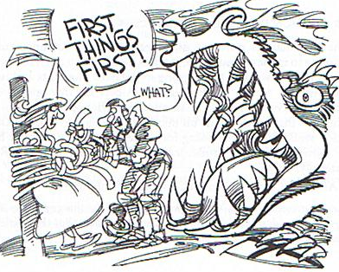

Have a wonderful weekend with your families.

Kind regards,

Mr. Matt Lecuyer - Headteacher