|  |  |  |  |  |  |  |  |  |
| --- | --- | --- | --- | --- | --- | --- | --- | --- |
| |  | | --- | | Friday 21st October 2016  The Mill Messenger | |  | |  | |  | |  | | --- | | Stars of the Week: Congratulations to: Isla, Declan, Precious, Addison, Fameeth, Renae, Gracie, Giulia, Jessica, Cadey, Sara, Sheri and Harrison.    **House Cup Winners:**  Congratulation to the Ambition house for winning this week with an impressive score of 22 points.  **Attendance Cup Winners**  Congratulations to Rousseau class in Year 5. The attendance for the week is 98.1%. Well done - take a bow you are this week’s attendance cup winners!  U:\Desktop\IMG_0208.JPG | |  | | **Key Dates:**  **Half Term –** Monday 24th – Friday 28th October  **Christmas Fair –** Friday 9th December  **Christmas Performances -** Monday 12th and Tuesday 13th December  **Last day of Term** – Friday 16th December | |

*“Strong people don’t put others down… they lift them up.”*  Michael P Watson

Dear Mums, Dads and Carers,

It was fantastic to see so many of you here on Monday and Tuesday at Parents Evening. We hope it was useful to see how you can support your child’s learning at home, where your child currently is in their learning and what their targets are moving forward. The partnership between home and school is a vital one and has such a positive impact on a child’s education. Thank you. If you were unable to attend, we will be sending an invite out after the break for you to make another appointment to see your class teacher. We feel it is imperative to have learning discussions with every child and their parent or carer.

Miss Dale’s assembly this week was about Habit number 4 – “Think; Win, Win.”

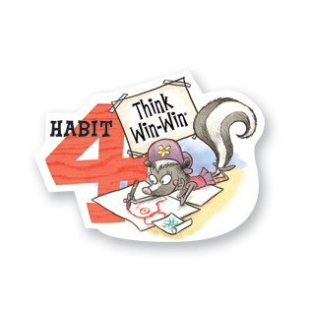

We asked the children to think about balancing courage for getting what they want with consideration for what others want. We spoke about a situation being better if we compromise and find ways that both parties can feel they have gained, rather than one side always losing. Furthermore, we discussed what an “Emotional Bank Account” is, and if we deposit in someone’s bank then we can withdraw from it when we need support also. Children were asked to reflect on when conflicts arise, to look for alternative options so all parties can feel listened to. Perhaps this might be something worth investigating as a family? When was the last time you deposited into your children’s emotional bank accounts?!

Thank you for all of your generous donations today in relation to non-uniform. The PTA and school are extremely grateful and these will go towards our stalls at the Christmas Fair on the 9th December. Again, if you are able to offer a hand, please let Shelley in the office know and she will pass your details on to Kim Nobbs our PTA chair.

Over the half term holiday why not try and do something different with your child? The National Trust have a list of “50 things to do before you are 11¾.” It includes activities such as flying a kite, going on a nature walk and climbing a tree etc. The list can be found at <https://www.nationaltrust.org.uk/50-things-to-do>. Let me know how you get on and email a photo if you have time!

Have an amazing half term break with your families and we look forward to welcoming you back to school on Monday 31st October.

Kind regards,



Mr. Matt Lecuyer

Headteacher