Dear Parents and Guardians,
We appreciate that this is a very challenging time for us all and hope that you and your family are staying well during this period. Our mission is to keep children reading throughout school closures and we want to support you in joining our mission! As such, we are working with TKAT to send out a weekly email with top tips and ideas to maintain reading for pleasure in your household.
What’s it all about?
As you may know, your child uses a programme called Accelerated Reader (AR) within school to guide their book choice and motivate them in their reading. After reading a book which is the right difficulty level for them, children take a short quiz and will earn points based on the length of the book and how well they understood it.
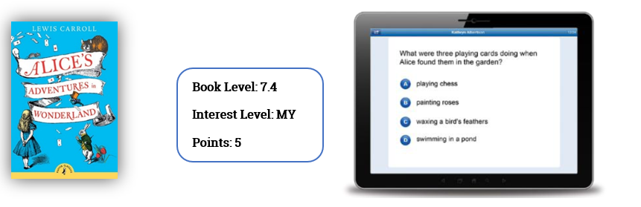
Children can continue to access and use Accelerated Reader as normal whilst the school is closed and The Mill Primary School’s site is available here: https://ukhosted64.renlearn.co.uk/2249176
Your child will have a username and password which is unique to them. If they are not sure what this is, please contact their class teacher.
What can they read?
School closures came upon us all very quickly and now that local libraries are closed, we may not all be as prepared as we would like for the weeks ahead!
Do not worry, there are some amazing ways for children to still access digital and audio books during closures, including our own site www.readon.myon.co.uk which has over 7,000 texts for them to explore – all for free!
With over 36,000 books AR quizzed and ready to go, fiction and non-fiction, you may find that between you already have some books available for children to engage with. To find out whether a book has an AR quiz, go to www.arbookfind.co.uk. Using the Advanced Search, you can also find some suggested books to match the ZPD range and interests of your child.
What is the ZPD range? 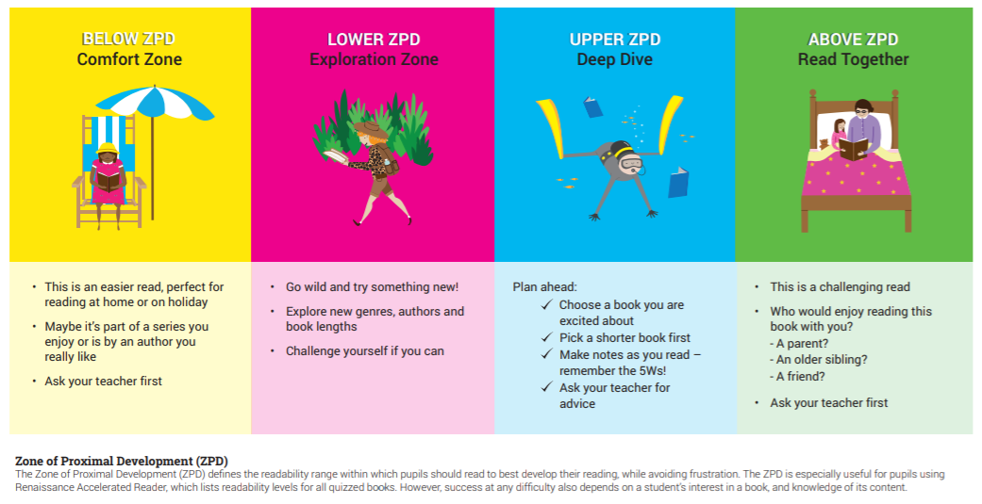

To make AR more effective your child will have taken a reading assessment called the Star Test. This finds the right level of reading for each individual child and provides them with a readability range for them to best develop, whilst avoiding frustration. The poster below helps to define the ZPD range and which books they should be selecting to read.
If your child cannot remember their ZPD range, they will be able to find it under the ‘Progress’ section when they login to AR.
Recommended reads of the week – available for free at www.readon.myon.co.uk
Don’t forget to encourage children to login to AR and take the quiz once they have finished reading!
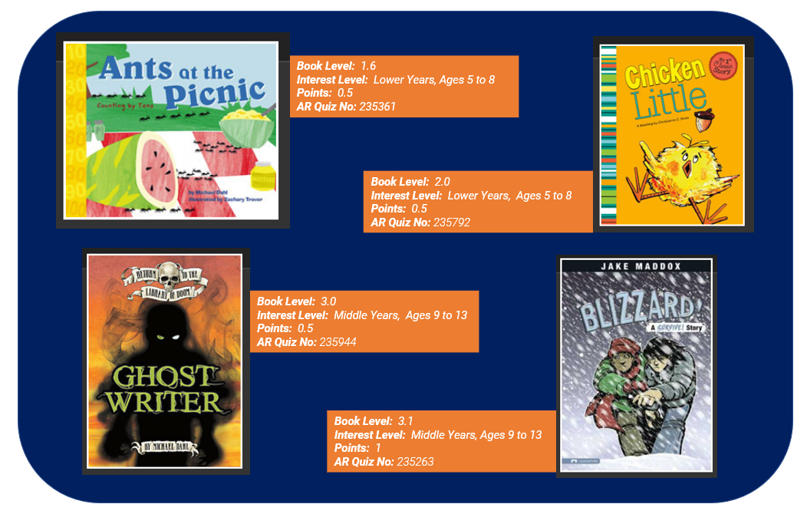
These are challenging and worrying times for us all but reading can be a great way to provide consistency and reassurance to children whilst they are away from school, as well as a much-needed escape!
If you have any questions or concerns, you can contact us at projects@renlearn.co.uk and do look at our twitter (@AccReader) for inspiration from other children and parents around the country who are embracing reading at this time!
Best wishes and speak next week,
Frances and Tamsin
The Projects Team

P: 020 7184 4000 | projects@renlearn.co.uk | www.renlearn.co.uk
14th Floor, South Quay Building, 189 Marsh Wall, London E14 9SH

