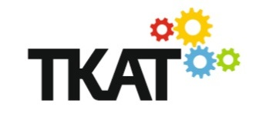
CONSTITUTION OF THE LOCAL GOVERNING BODY OF

The Mill Primary Academy

Part of The Kemnal Academies Trust

15th November 2022

- The names of the Academy governed by this Local Governing Body is The Mill Primary.

- The name of the Local Governing Body (LGB) is The Local Governing Body of The Mill Primary.

- The Local Governing Body shall be constituted of up to 10 Governors.

Class of Governor | Number
Headteacher (ex-officio) | 1
Staff | 2
Parents | 2
Appointed | 5
Total | 10

- The Term of Office for each class of Governor shall be in accordance with the Scheme of Delegation of the LGB as granted by the Directors of The Kemnal Academies Trust.

- This Constitution is made by The Kemnal Academies Trust and The Local Governing Body of The Mill Primary academy effective from 15th November 2022.

On behalf of TKAT  Karen Roberts  CEO | On behalf of the LGB  Ben Cooper  Chair of Governors

